## Instructions to run the application:

Needs Java 18 installed in the system that is running the program.

### Instructions to run the MAVen application:

* File Structure:

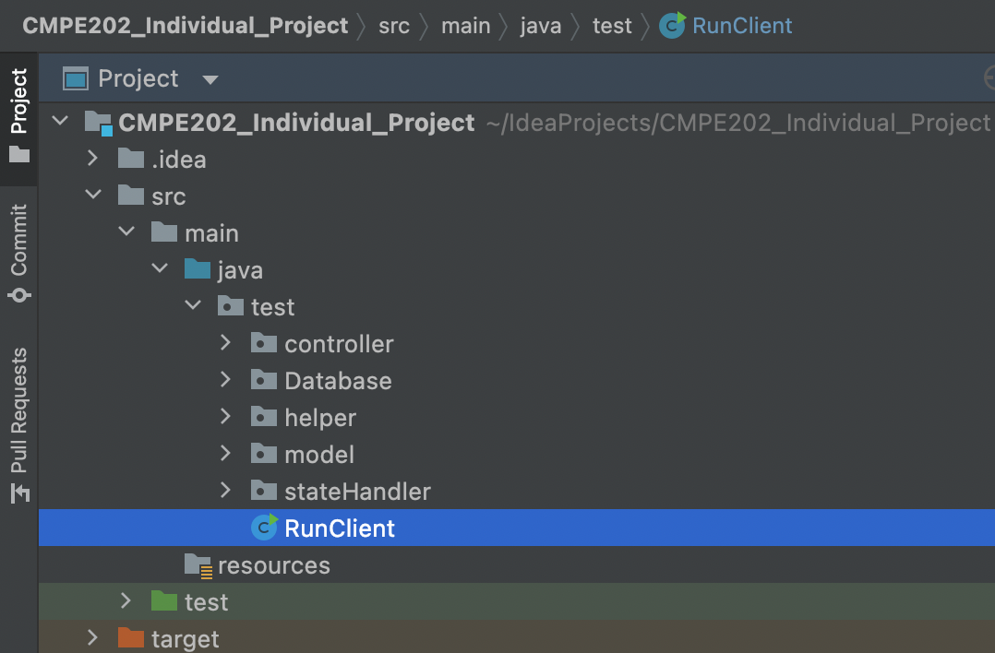

* Open Command Prompt in the main directory - **Go to CMPE202 Individual Project**.  
   Run below commands in the sequence to install the maven project –

mvn compile

mvn clean install

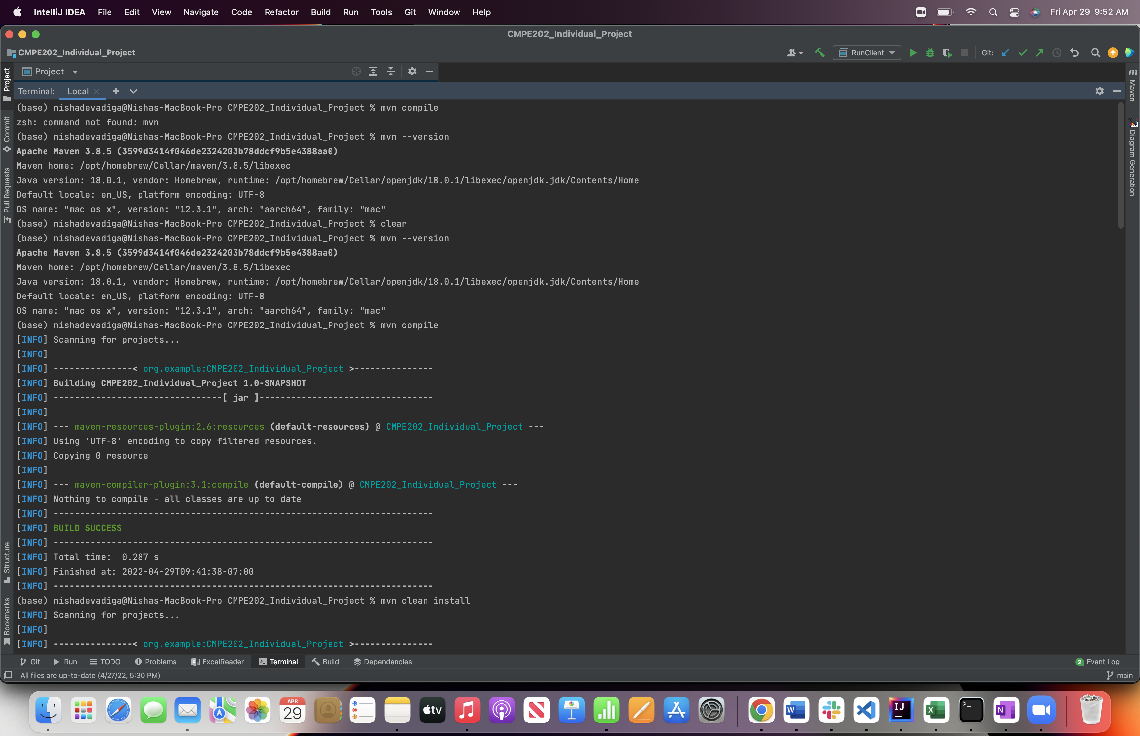

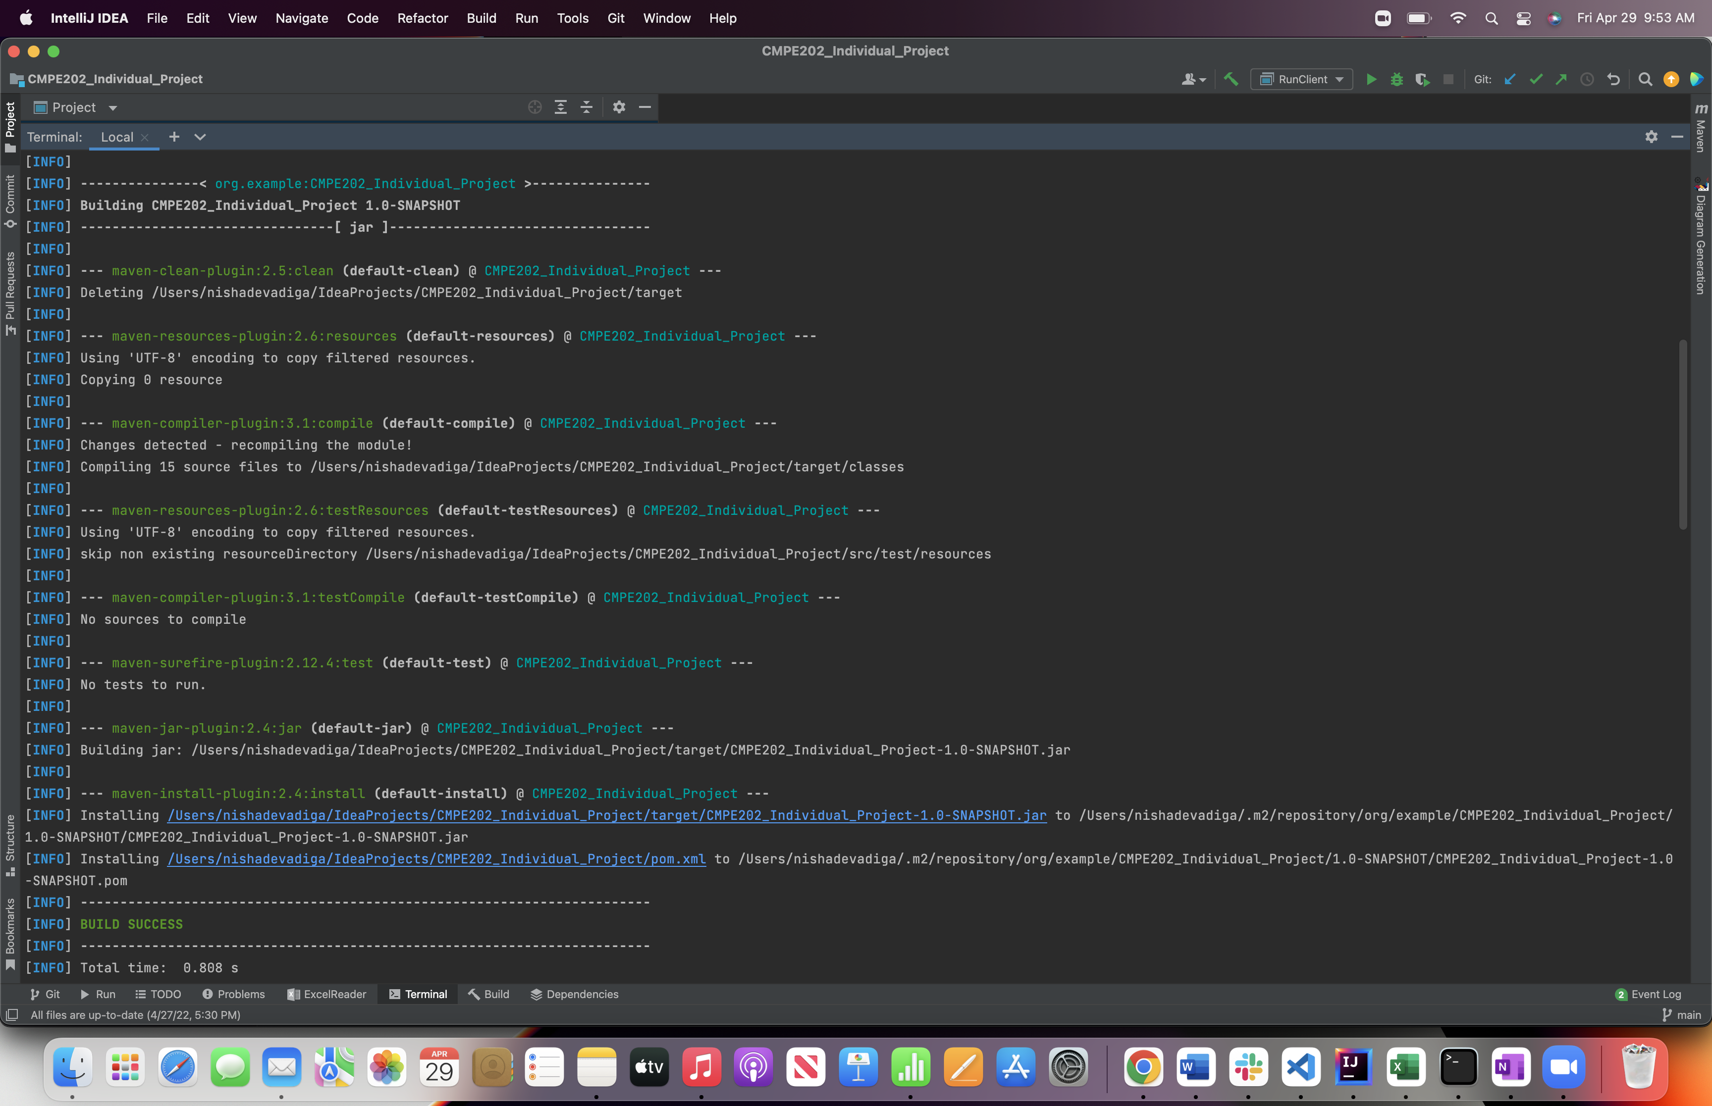

* Run the following command in the command prompt:

mvn exec:java -Dexec.mainClass=test.RunClient -Dexec.args="<Path to Input Data> <Path to Flight details to populate DB>"

**For Example:**

1. For Input File 1: -

mvn exec:java -Dexec.mainClass=test.RunClient -Dexec.args="InputFile.csv flights.csv"

1. For Input File 2: -

mvn exec:java -Dexec.mainClass=test.RunClient -Dexec.args="InputFile1.csv flights.csv"

1. For Input File 3: -

mvn exec:java -Dexec.mainClass=test.RunClient -Dexec.args="InputFile2.csv flights.csv"

1. For Input File 4: -

mvn exec:java -Dexec.mainClass=test.RunClient -Dexec.args="InputFile3.csv flights.csv"

1. For Input File 5: -

mvn exec:java -Dexec.mainClass=test.RunClient -Dexec.args="InputFile4.csv flights.csv"

* Output files will be created in the directory as the files provided as arguments to run the command.

## Primary problem:

We will build a flight booking application which maintains an internal, static database (inventory of flight details) created using HashMap. The data will contain the following tables and fields:

Table 1: Flights

* **Category**(Economy, Premium Economy, Business)
* **Flight number**
* The available **Seats** of each category
* **Price**of each seat
* **Arrival City**
* **Departure City**

Input CSV file contains booking details including booking name, flight number, seat category, number of seats, and the payment card number. Here we will need to perform few validations on seats, flight, and card details.

The primary problem is to decouple a request's sender and receiver when handling the validation requests. Multiple objects, determined at runtime, are candidates to handle a request. Here specifying handlers explicitly in the code could lead to non-reusability. To overcome this problem, we opted for Chain of Responsibility design pattern that solves the problem by designing flexible and reusable object-oriented software. That is, objects are easier to implement, change, test, and reuse.

## Secondary problems:

The secondary problem is related to utilization of heap memory by allowing to create the copies of objects for the database. In this case, single database object is good enough to perform the operations in the project for various operations. To solve this problem, we use Singleton Design Pattern that restricts the instantiation of class to only one object.

The next secondary problem is tight coupling and poor level of abstraction where complexities of code and internal implementation is visible to user. To avoid this, we need to perform encapsulation by implementing Factory Design pattern.

## Design pattern(s):

* Singleton
* Factory
* Chains of Responsibility

### Singleton:

* It is creational design pattern that lets you ensure that a class has only one instance, while providing the global access point to this instance.
* This pattern is used to build the database for the application. Only the Database class is used as part of this pattern.
* Whenever an instance of the database is needed, the getInstance() method is called so that only one instance of the object can be reused.

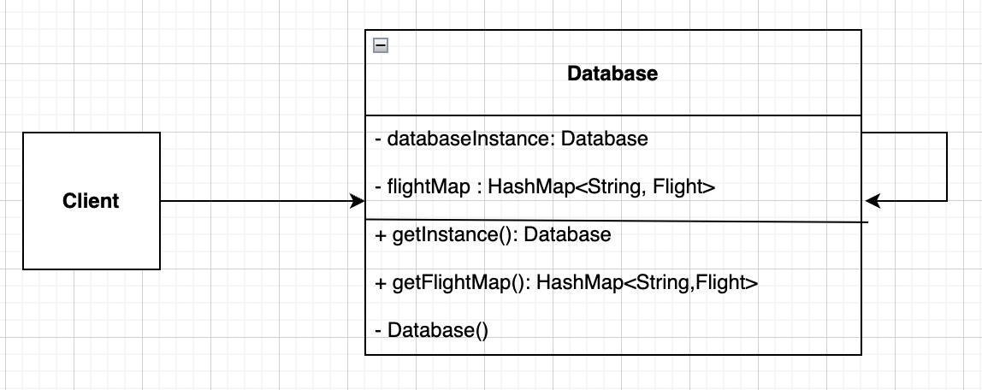

### Factory:

* It is a creational design pattern that provides an interface for creating objects in a superclass but allows subclasses to alter the type of objects that will be created.
* We have used this pattern to output when an order is processed. The following files are as part of this pattern implementation:
  + Interface OutputFile
  + Class CheckoutFile
  + Class ErrorFile
* When the respective concrete handler figures out the output should be a checkout file or error file, we will create an object of OutputFile. The FileReader class is used to read and create files in the application.

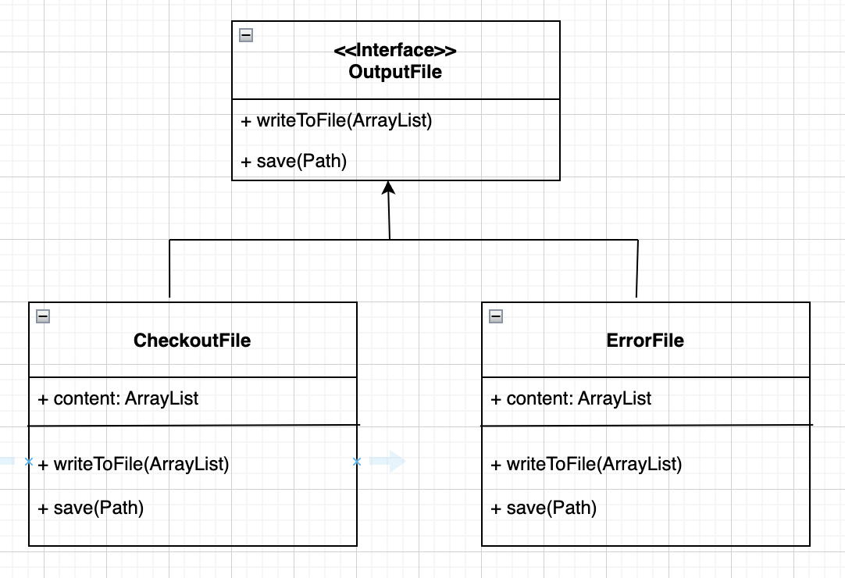

### Chains of Responsibility:

* It is a behavioral design pattern that lets you pass requests along a chain of handlers. Upon receiving a request, each handler decided either to process the request or to pass it to the next handler in the chain.
* We have used this design pattern to determine if the order can be processed correctly or not. The following files are used in this pattern:
  + Interface ValidationHandler
  + Class FlightPresenceValidation
  + Class FlightSeatValidation.
  + Class CardValidation
* Before we verify the order can be processed or not, ValidationHandler object is created and will be passed on from one Handler to another using the same.

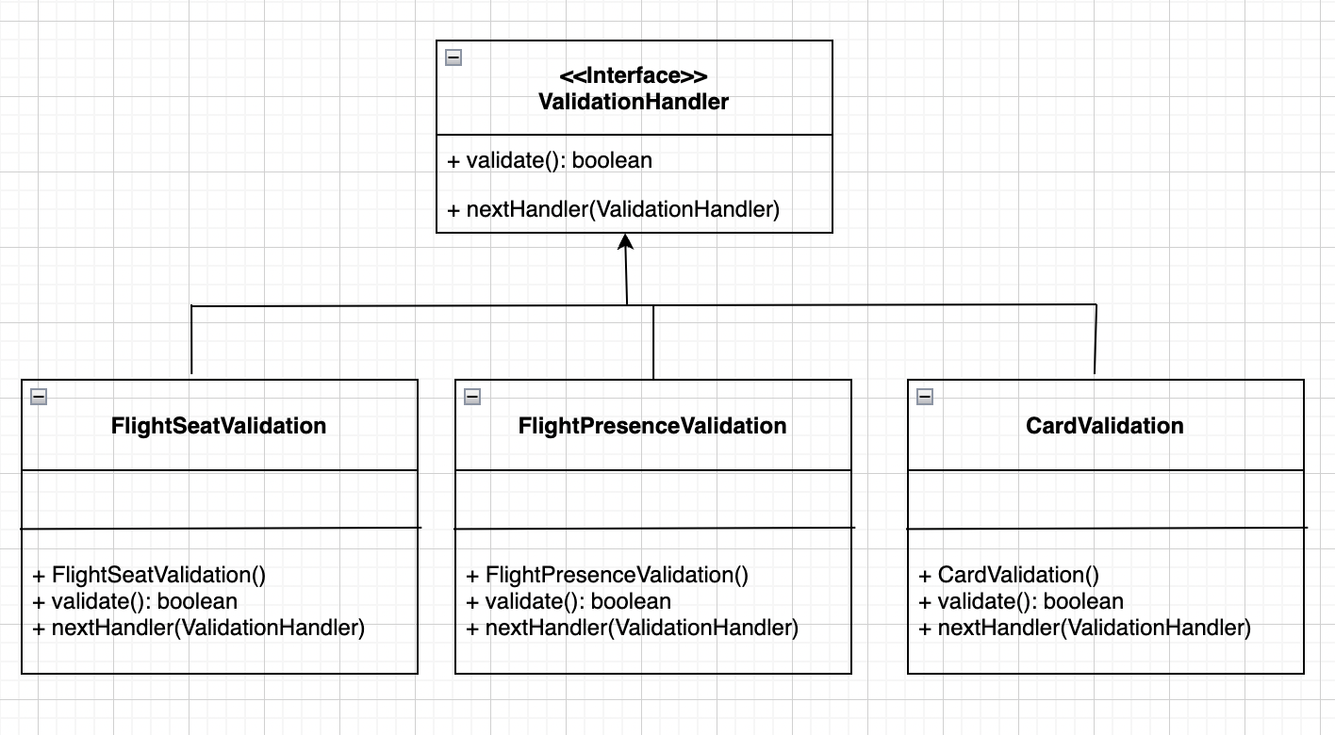

## Consequences of using these pattern(s):

*Singleton*

The Singleton pattern solves below two problems at the same time but by violating the Single Responsibility Principle:

1. Ensures that a class has just a single instance – Database Class Instance is instantiated only once to avoid creating a new one.
2. Provides a global access point to that instance – Just like a global variable, the Singleton pattern lets you access Database object from anywhere in the program. However, it also protects that instance from being overwritten by other code.

*Chain of Responsibility*

Using Chain of Responsibility, two important principles of SOLID can be achieved.

1. Single Responsibility Principle - You can decouple classes that invoke operations from classes that perform operations.
2. Open/Closed Principle *-* You can introduce new handlers into the app without breaking the existing client code.

*Factory*

1. Provides hooks for subclasses. Creating objects inside a class with a factory method is always more flexible than creating an object directly.
2. Factory Method gives subclasses a hook for providing an extended version of an object.

## Class diagram:

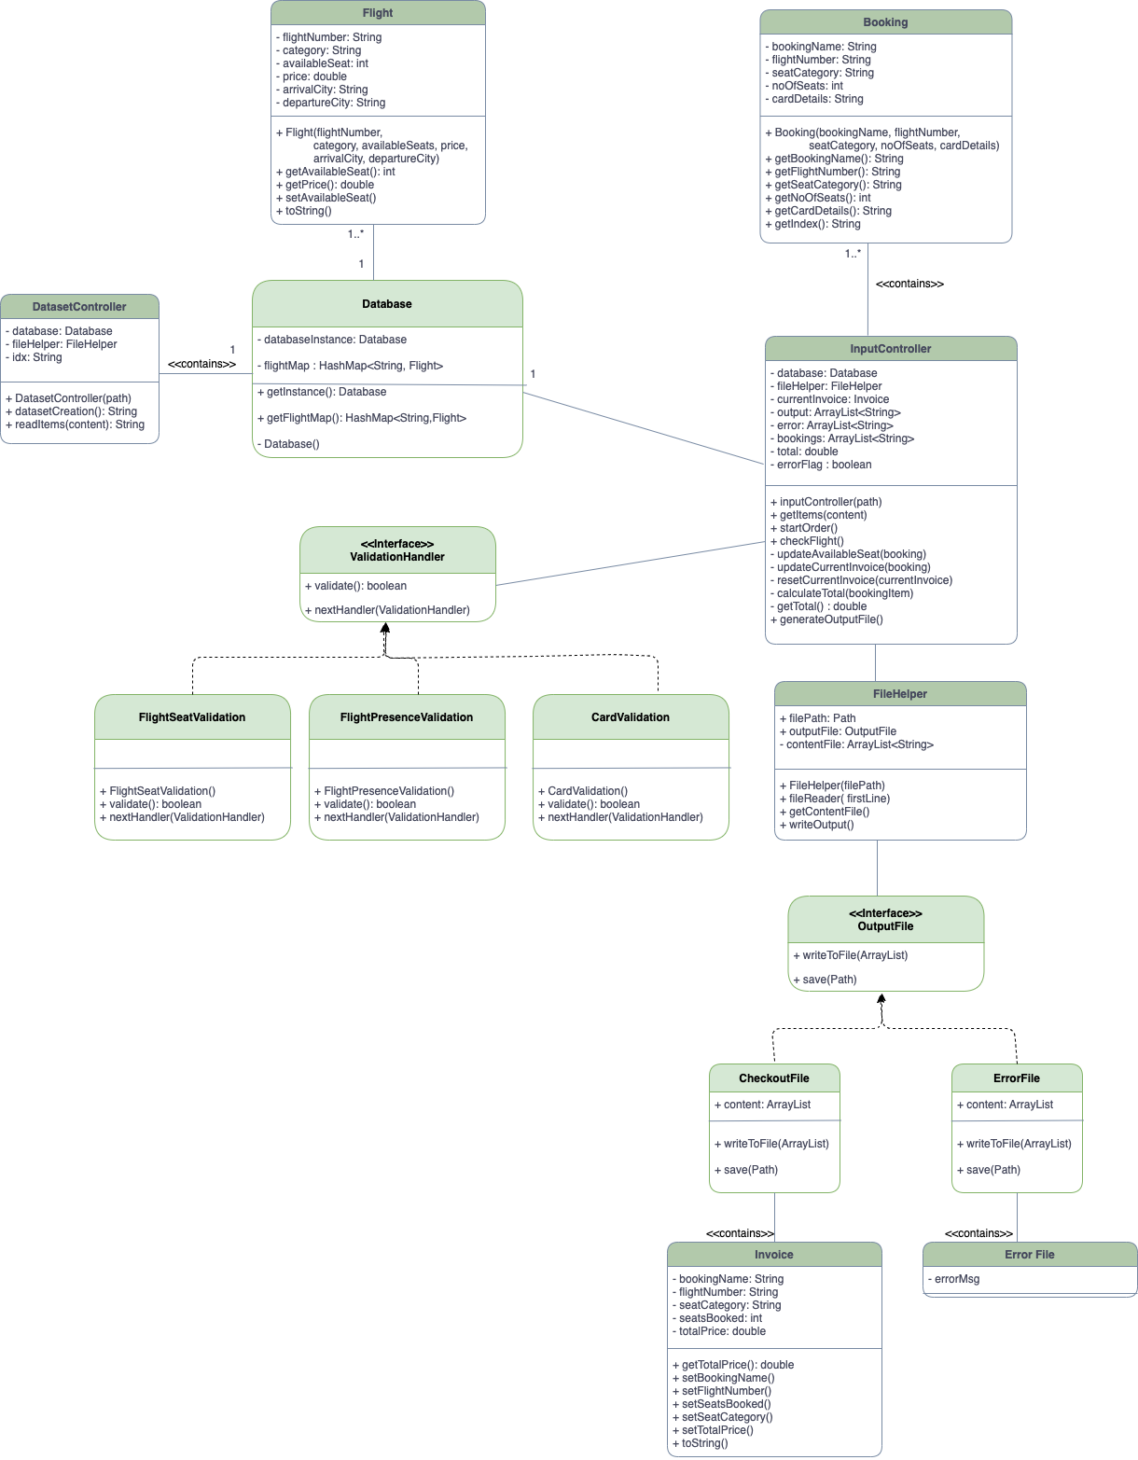

## Junit test cases should be written for all the design pattern classes/methods. Screenshots of test execution and result should be included:

**Flight DB:**

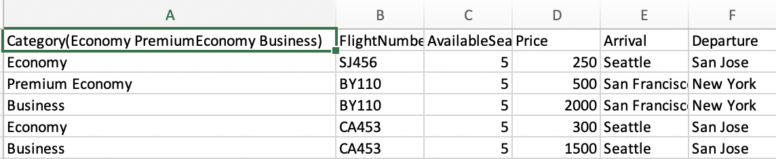

**Test Case 1 – Non- Existent Flight in the input file.**

* + Input File:

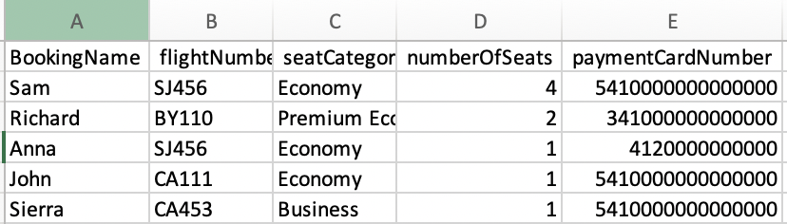

* + Command:

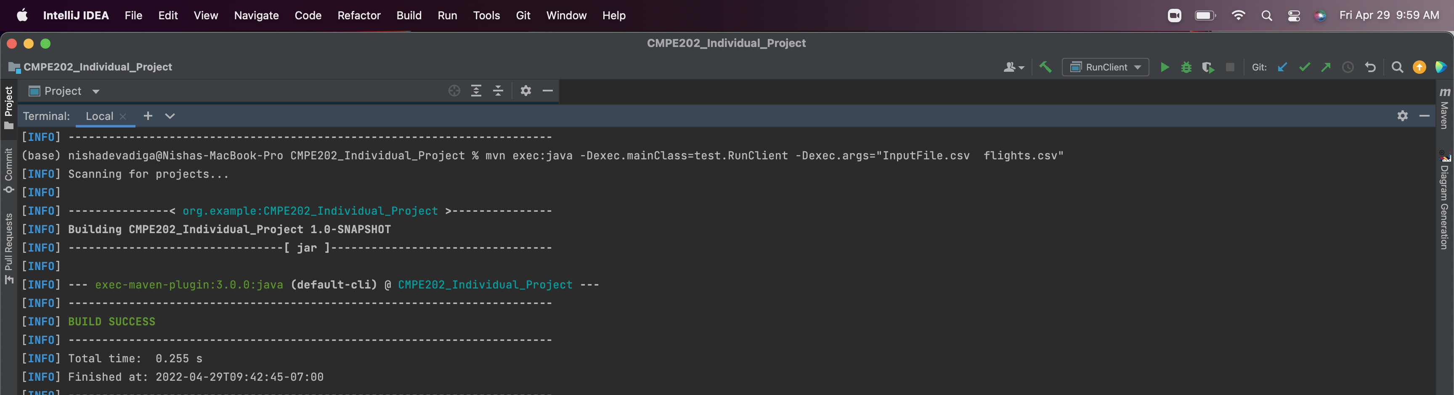

* + Output File:

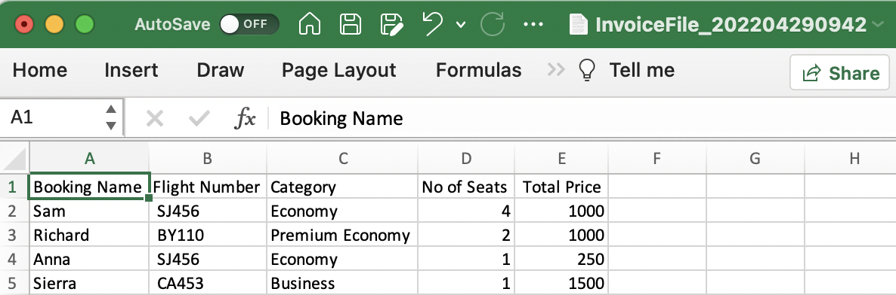

* + Error File:

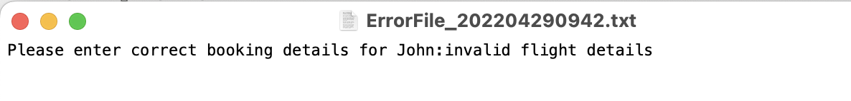

**Test case 2 – Seat Unavailable for Flight SJ456 - Economy**

* + Input File:

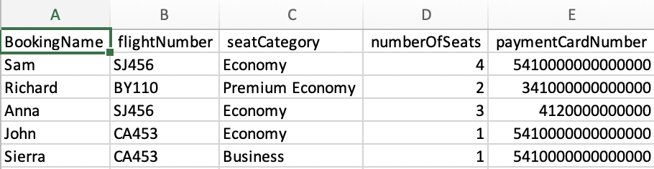

* + Command:

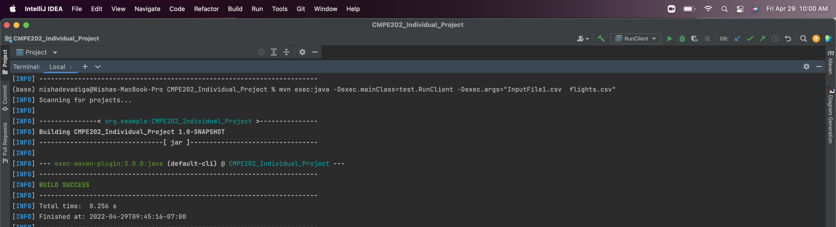

* + Output File:

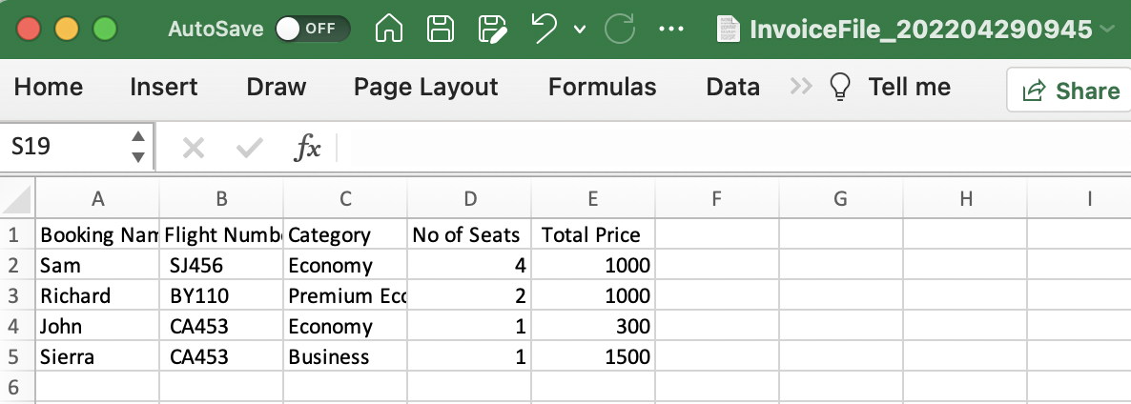

* + Error File:

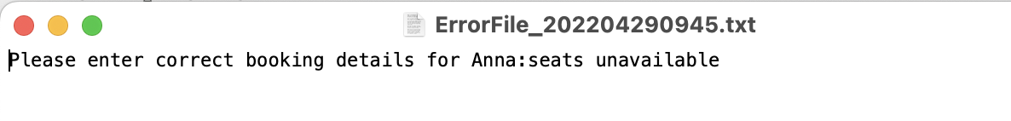

**Test Case 3 – Flight No present but Category not Present in Flight Database. For example - CA453 & Premium Economy.**

* + Input File:

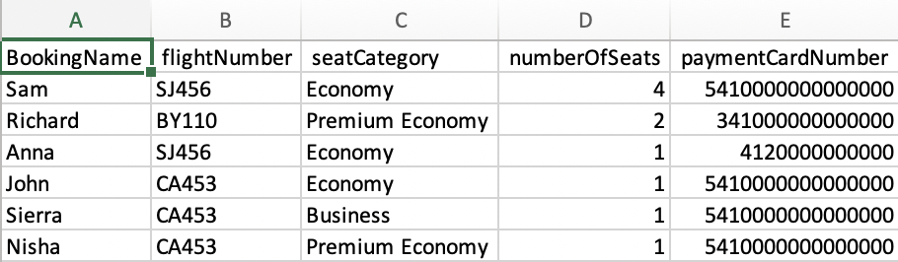

* + Command:

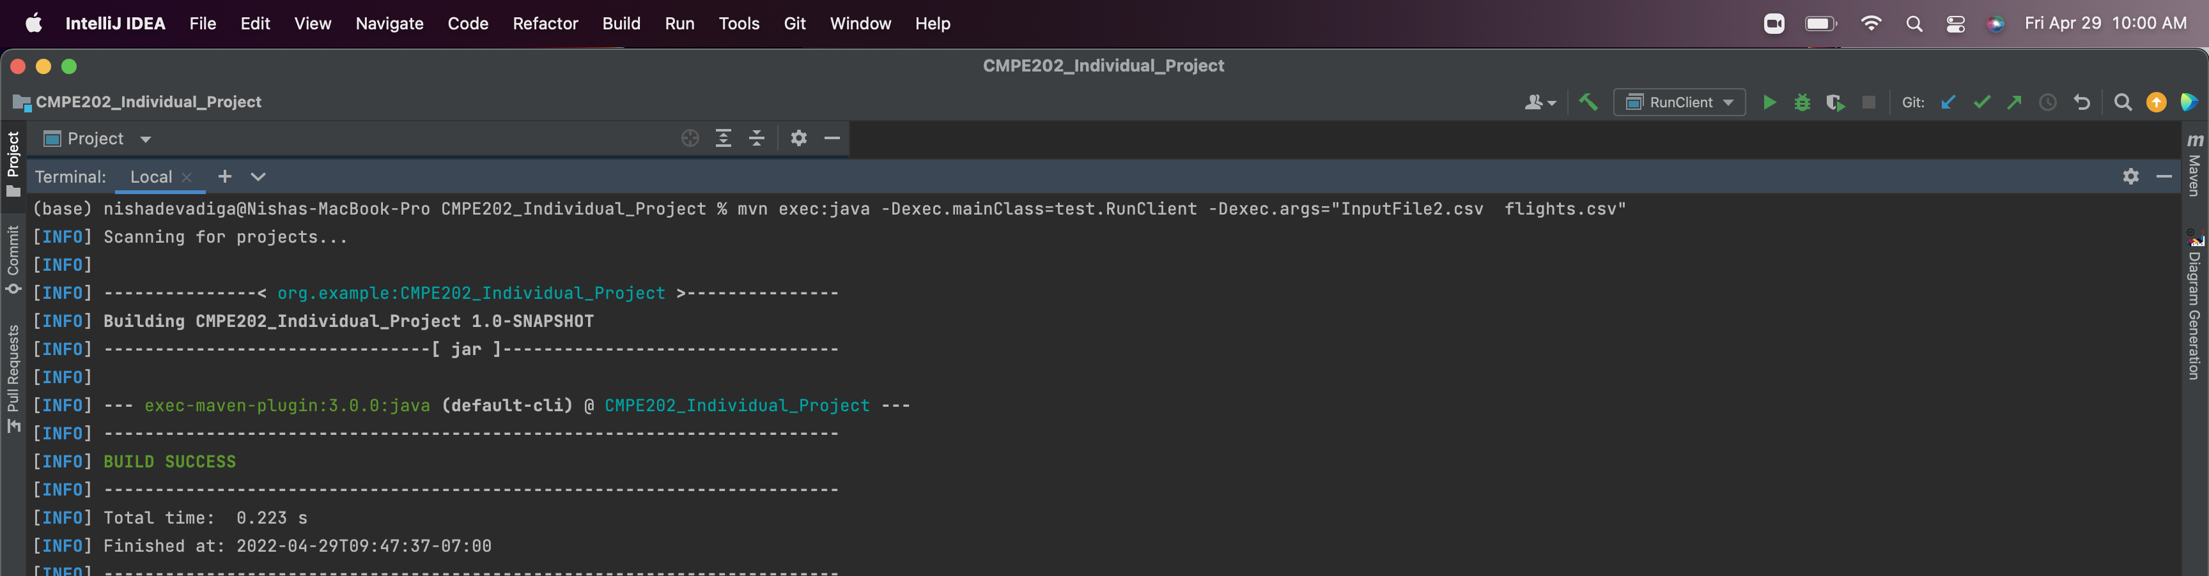

* + Output File:

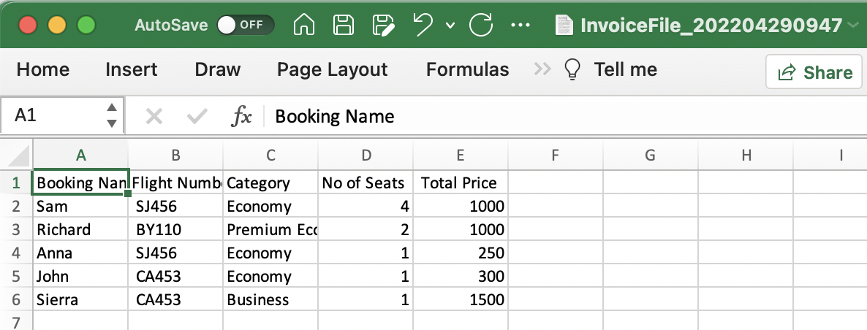

* + Error File:

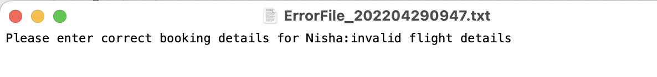

**Test case 4: All Validations Passed**

* + Input File:

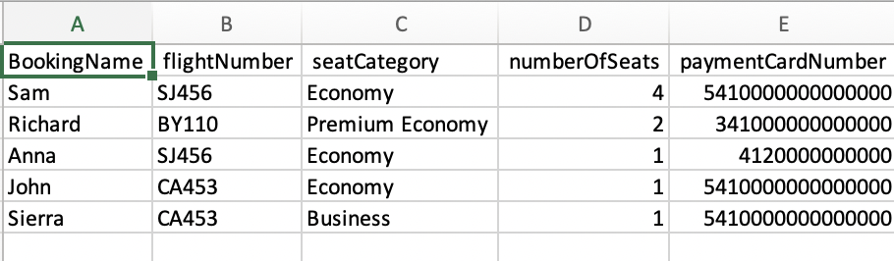

* + Command:

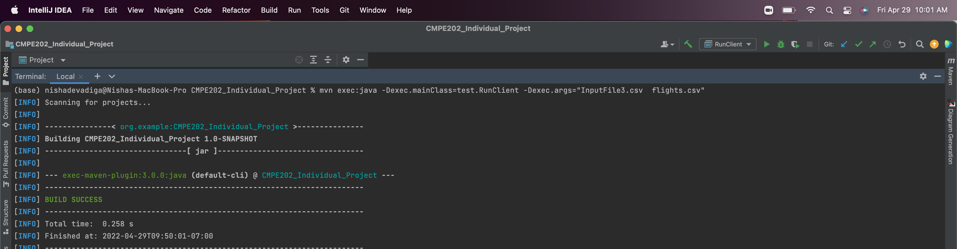

* + Output File:

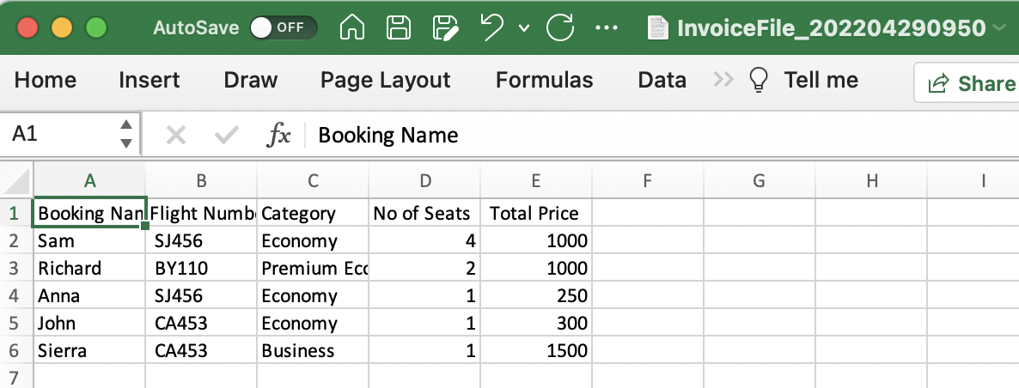

* + Error File:

**No error File Generated.**

**Test case 5: Invalid Card details**

* + Input File:

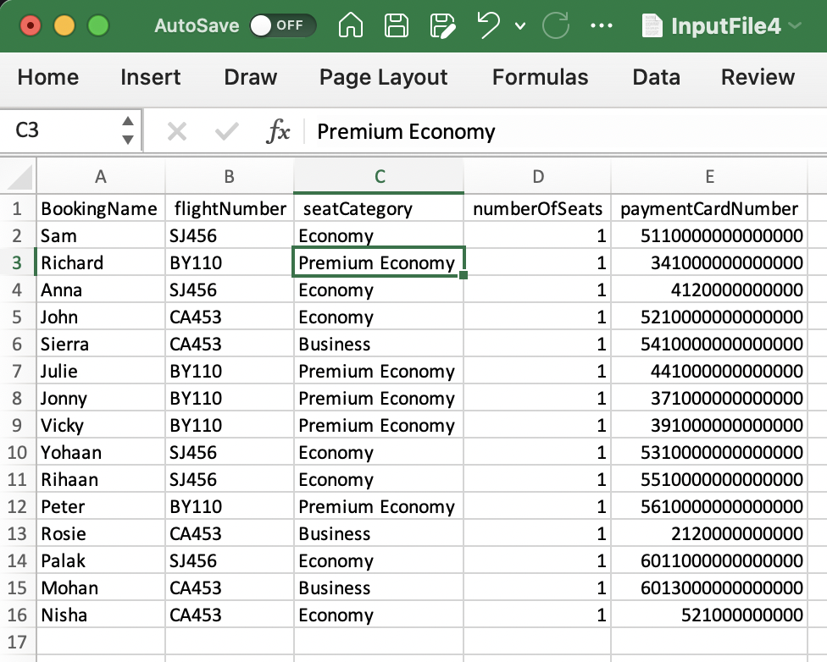

* + Command:

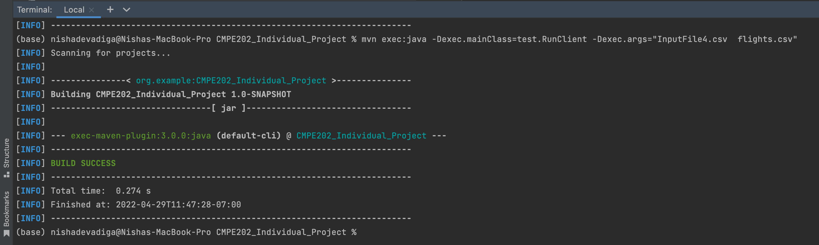

* + Output File:

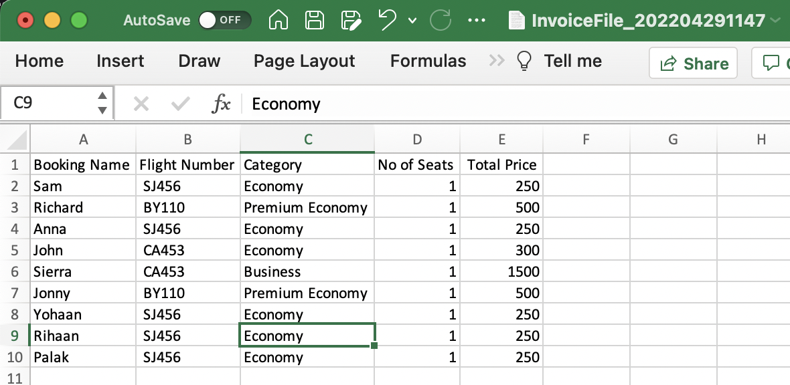

* + Error File:

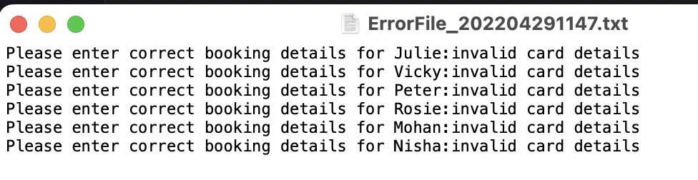

**JUNIT Test Snapshots: -**

* + **Static Database Creation:**

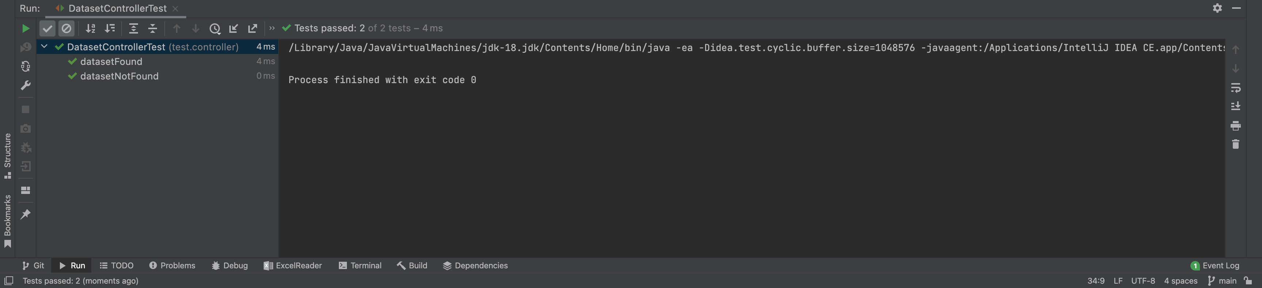

* + **Input Controller Validation:**

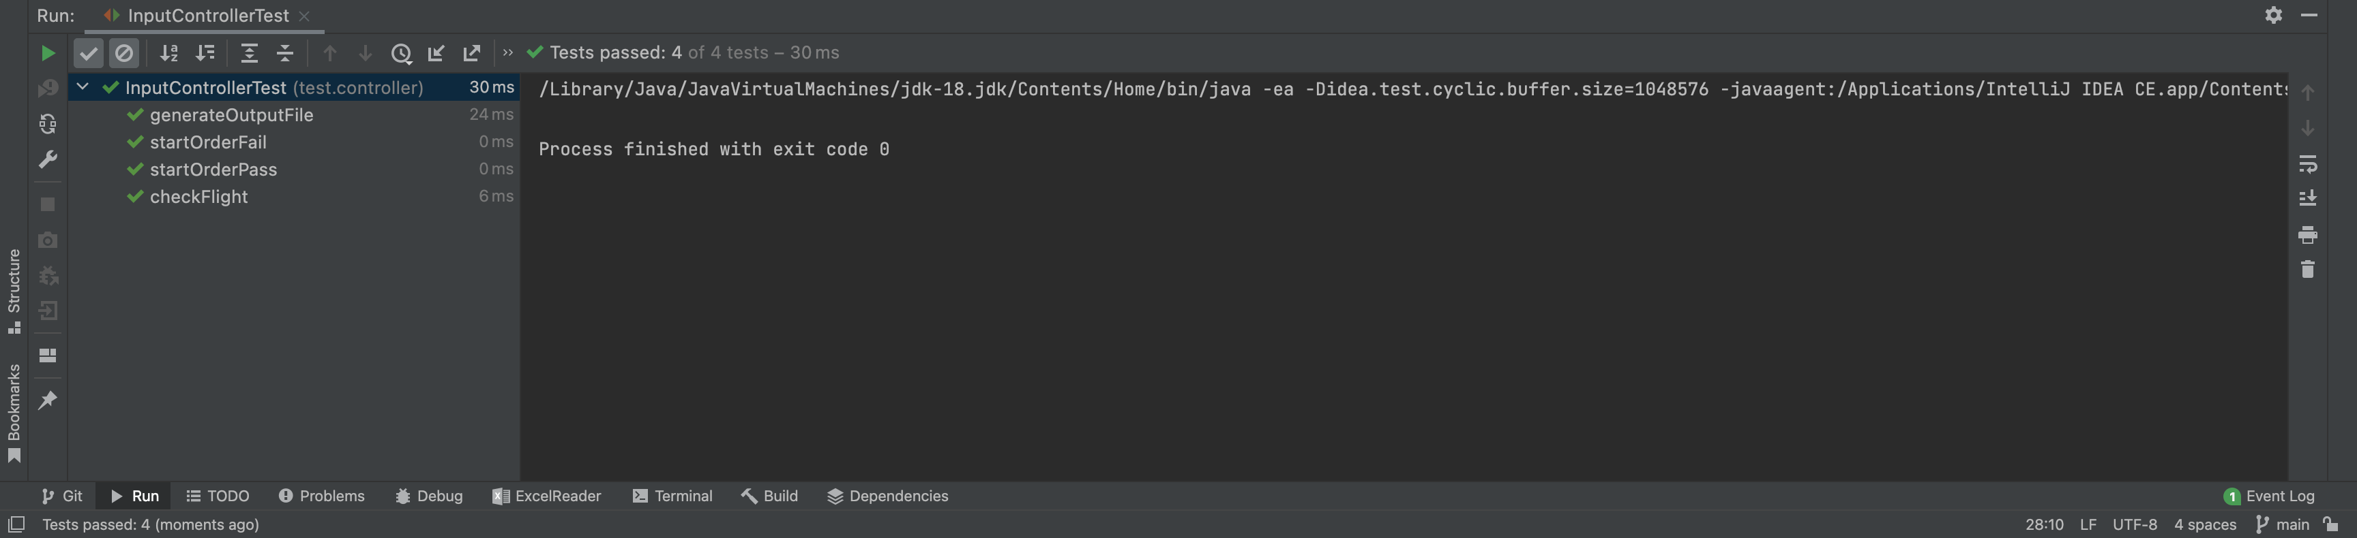

* + **Seat Validation:**

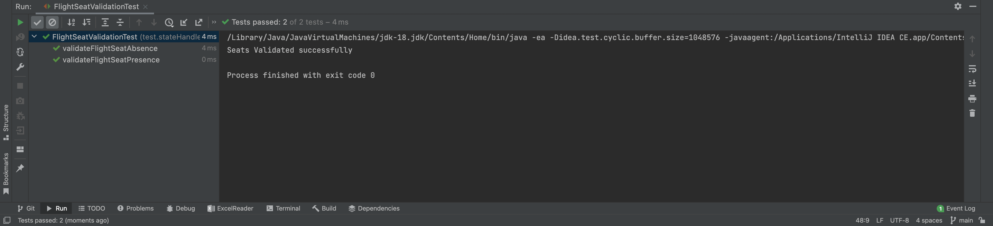

* + **Flight Validation:**

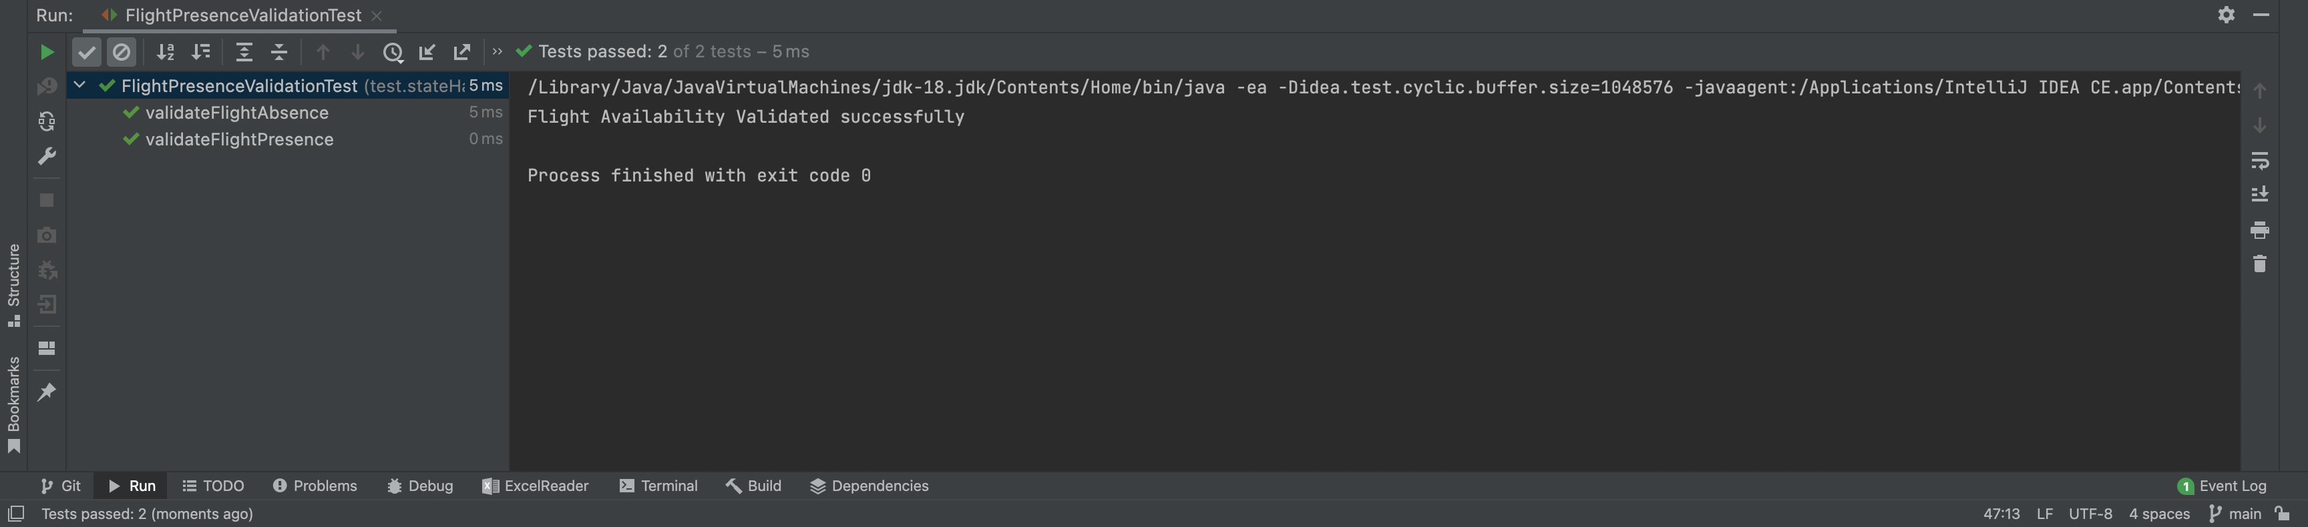

* + **Credit Card Validation:**

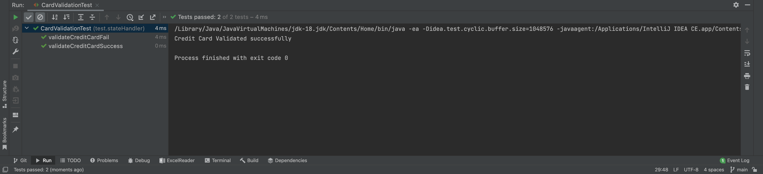

* + **Error File Creation validation:**

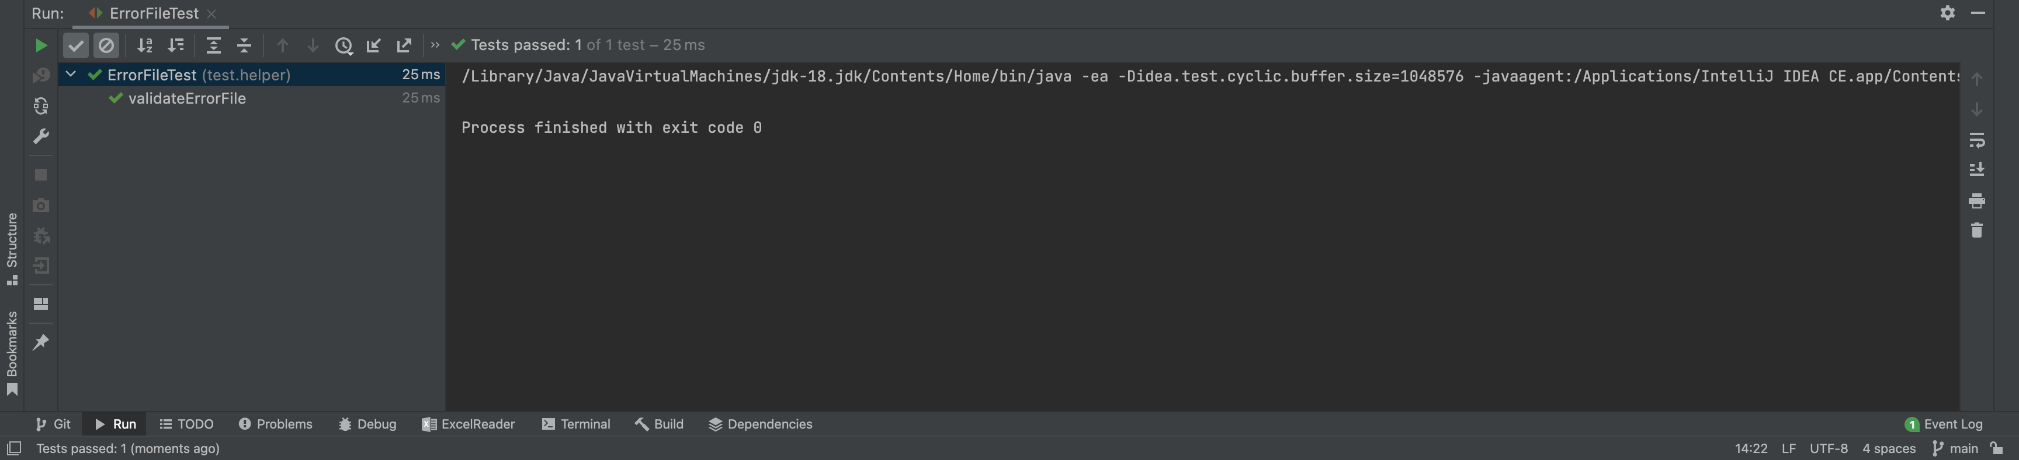

* + **Checkout File Creation validation:**

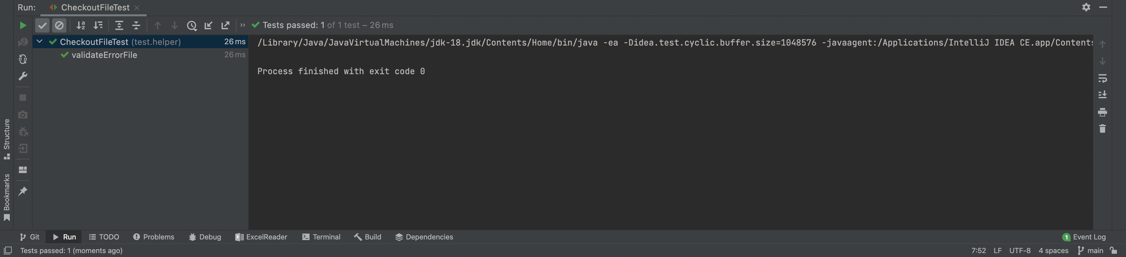

**GITHUB Link -** [**https://github.com/gopinathsjsu/individual-project-NishaMDev**](https://github.com/gopinathsjsu/individual-project-NishaMDev)